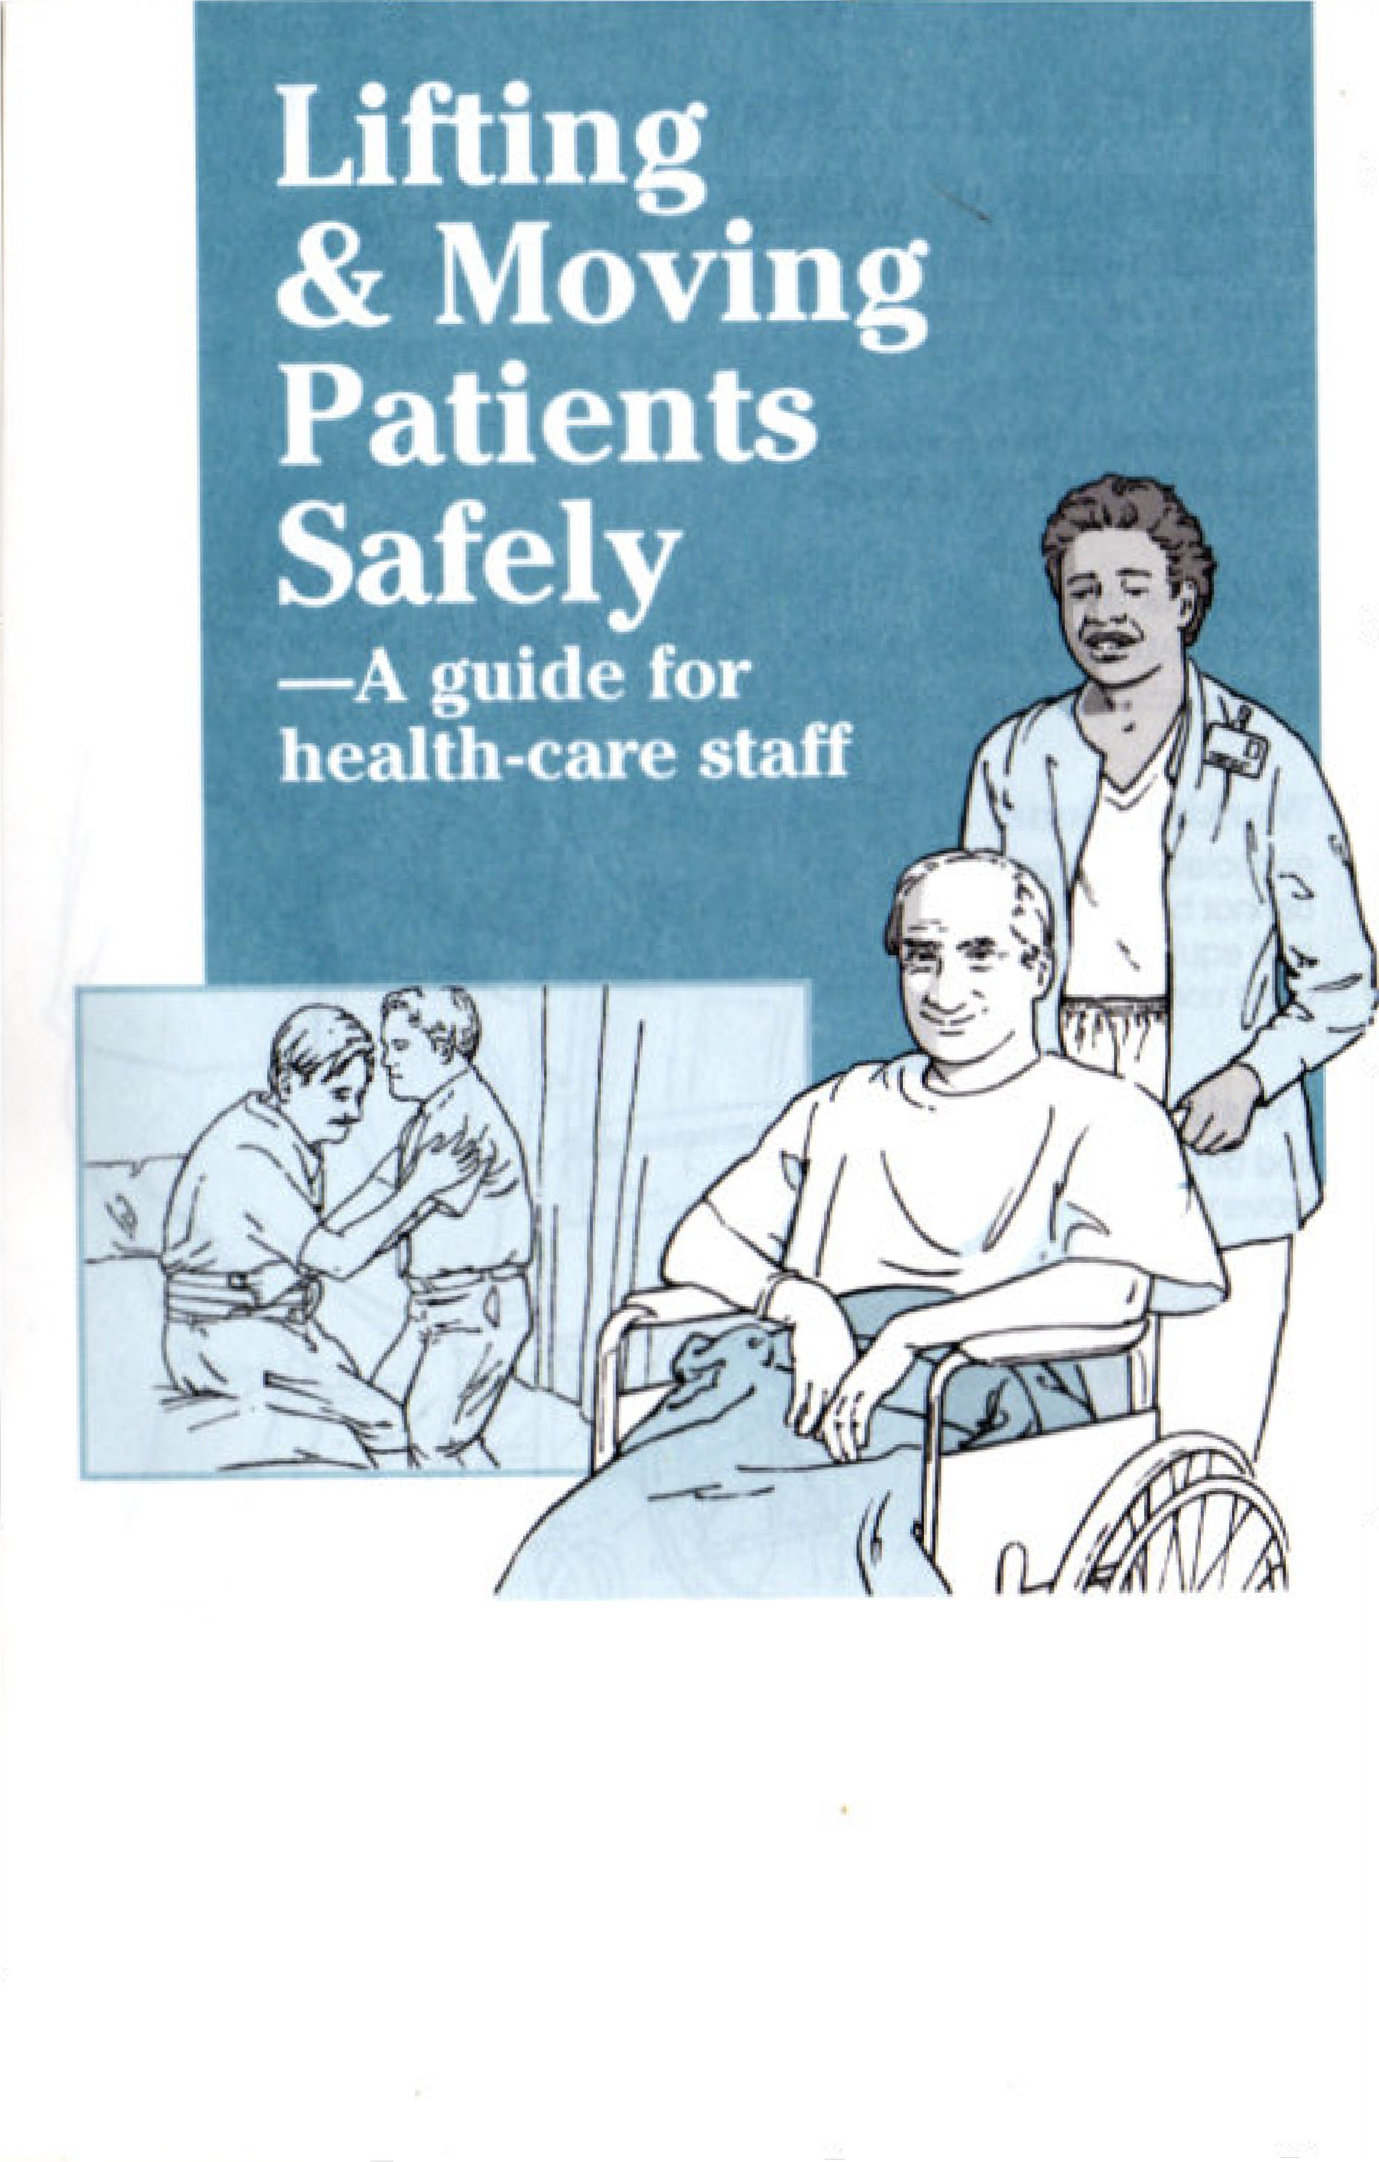

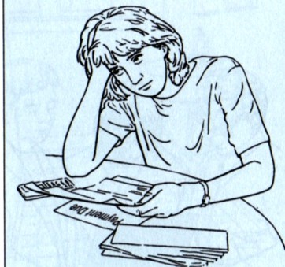
Lifting and moving patients is a major cause of injury
Both patients and staff are at risk.
Improper lifting and moving increases the risk for:
Cuts and bruises Strains and sprains,
especially to the upper and lower back, neck, shoulders, wrists, hands and knees
Broken limbs Lasting disabilities,
such as chronic back pain.
Lifting and moving injuries can be prevented.
Help make every move a safe one!
The costs of lifting and moving injuries are high.
For employees, they include:
- lost time at work and loss of wages
- higher medical expenses.

For employers, they include:
- added legal costs and patient complaints
- higher workers' compensation and insurance costs
- staffing shortages.
in health-care facilities. Most lifting and moving injuries result from:

Patient transfers
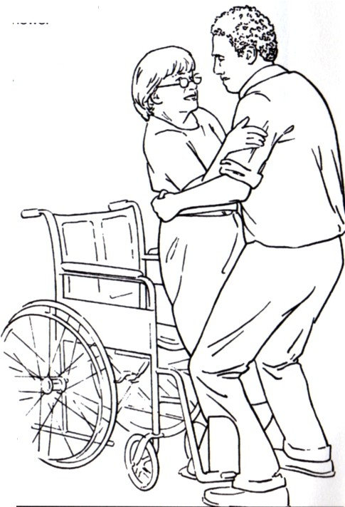
-for example, from bed to wheelchair, chair to toilet or toilet to shower

Patients who
move unexpectedly
or are uncooperative

Working alone, especially if the patient cannot bear weight and equipment isn't used correctly

Twisting
and other sudden movements

Working in
a confined space,
such as a bathroom

Slips, trips and falls.

Please read:
This booklet is not a substitute for knowing state and federal regulations for lifting and moving patients. It does not take the place of your employer's health and safety policies, or of proper training and practice.

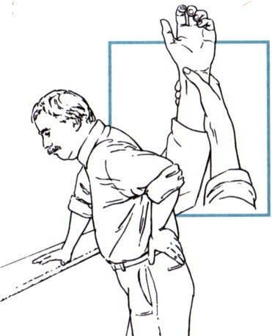

3

Assess the situation first.
Remember that each move is different.

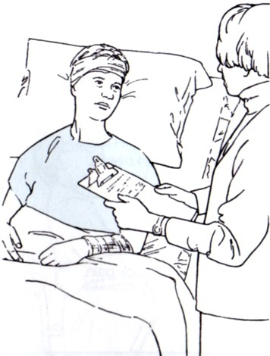
What are the patient's abilities and limitations?
- What is his or her condition? What are his or her vital signs? Are there any bandages,
IV tubes or other things to consider?
- Is he or she strong and flexible enough to help?
- How much does he or she weigh? Can the patient bear any of his or her own weight?
- What are his or her mental abilities? Are these affected
by medications? Can he or she follow directions?
- Does he or she have proper footwear?What equipment-such as a transfer belt (also called a gait or walking belt) or a mechanical lift-is appropriate for this move?

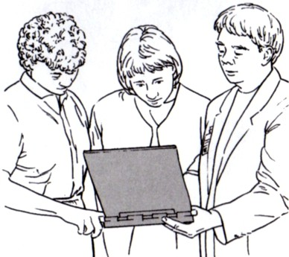
Learn as much as you can about the patient.
- Review the patient's chart and medical records, if authorized. (Some facilities also use color-coded transfer stickers on patient beds or doors.)
- Consult other staff.
- Talk with the patient-and family members, friends, patient advocates and home caregivers, if possible.
4

What are your abilities and limitations?
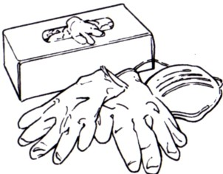
Going beyond them increases the risk of injury.
  - Have you been properly trained? This includes training in proper lifting and moving techniques for that move-and in the use
of equipment.
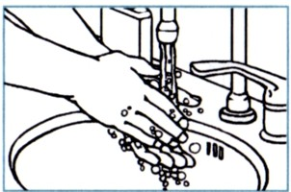
  - Are you wearing proper footwear (shoes with nonslip soles)?
  - Could required PPE (personal protective equipment) affect the move? Gloves, masks and other PPE can affect your grip and vision.
(Also make sure you have washed your hands. This reduces the risk of spreading diseases.)

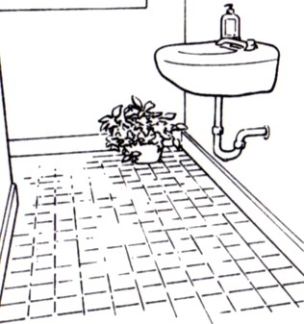
How safe is
I--
JJ
the environment?
Even for a short move, a clear path is essential for safety.
Check for potential hazards. These include:
  - electrical cords
  - loose carpeting and slippery floors
  - wet surfaces
  - furniture, boxes and other obstacles
  - sharp edges
  - poor ligh�ing and blind spots.
If hazards cannot be removed or avoided, plan a new move.

Always think "safety first" before you begin a move.
5

Prepare for the move.

In general, moves should not take place just by manual handling (not using any kind of assistive equipment).

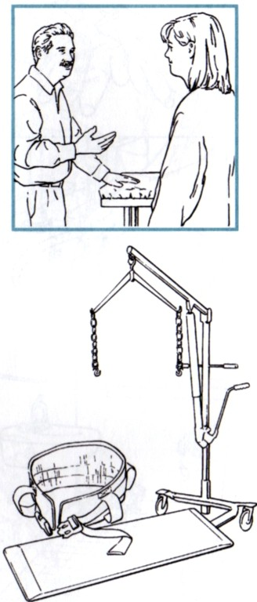
Get help, if you need it.
Many lifts or moves may require two or more trained staff people to do a team lift, including when a patient is:
- unable to help, due to his or her physical or mental condition
- uncooperative or at risk of becoming violent.
If you have any doubts about a move, ask for help.

Get the equipment you need. In addition to team lifts, you may need to use:
- mechanical aids (such as lifts or hoists)
- assistive devices (such as a sliding board, a transfer or turn sheet or a transfer belt).
Be sure the equipment is:
- free of defects and in proper working condition
- appropriate for the patient's size and condition, and the type of move.
Remember, be sure you are trained and authorized before using any equipment. Ask for help if a move requires equipment you are not trained or authorized to use.

Prepare the patient.

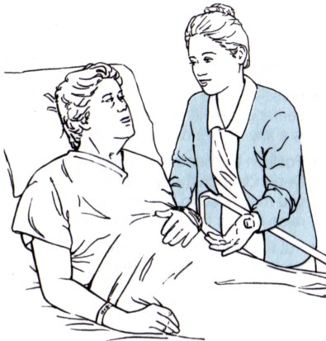
Moves are safer when patients and staff work as a team.

Explain what will happen
and why. Be sure to explain
possible risks, too.

Give clear instructions to patients who can help with the move. Go step by step. For some patients, it's best to show them exactly what they need to do.

Ask if there are any questions
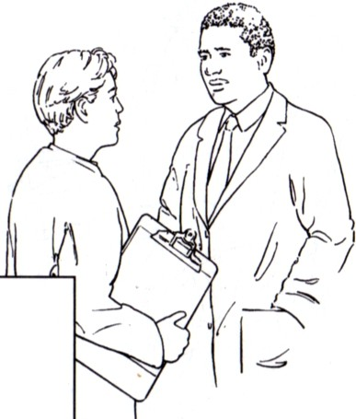
or concerns. For patients
who can help, also ask them to repeat your instructions in their own words.

Get patient consent, if required
-check with your supervisor or the attending physician first.
Proper training and practice are critical.
Make sure you know and follow proper procedures at all times. If you have any questions, ask your supervisor-before you begin a move.
Never take chances or shortcuts.

Manual handling may be unavoidable in some cases, such as in an emergency. Some facilities may also allow it in certain other cases, such as moving a small child or not having to lift most or all of a patient's weight. Be sure to know and follow your facility's policies.
6 7

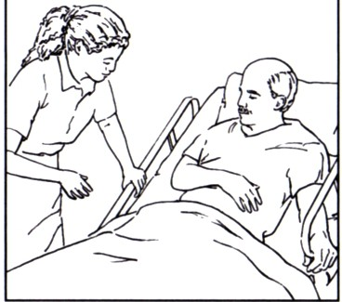
Position and adjust equipment properly.

Adjust the bed.
- Raise or lower it close to your center of gravity. In general, this is a few inches below your waist.
- Position the head of the bed. Depending on the type of move, you may need to lower it flat or raise it to its full, upright position.
- Put the side rails up or down, as needed. Lock the wheels.

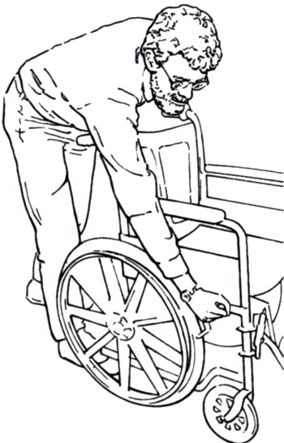
Position the equipment.
  - Place the wheelchair or stretcher as close to the patient as possible.
  - Align it properly. For example, a wheelchair should be placed parallel (or at a 45° angle) to the bed.
  - Adjust the side or handrails as needed.
  - Move footrests out of the way. Lock the wheels.

Make needed adjustments.
  - Keep the bed and the equipment at the same height, if possible. Adjust as needed.
  - Make sure the patient and any helpers are properly positioned.
8

Always use proper body mechanics.
This means using your body correctly for every lift andmove. Here are some general guidelines:

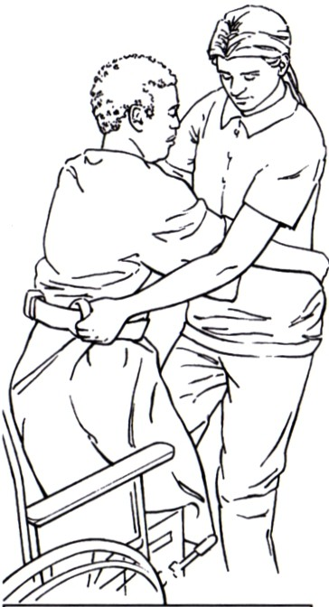
Maintain your balance.
Everyone has natural limits
(size and strength, for example). Following the guidelines above and using the right equipment for each move can help you stay safely within those limits.
- Tighten your stomach muscles and tuck your pelvis (the base of your spine).
- Keep your feet apart for a stable base.

Get a sure grip.
- When using a transfer belt, for example, make sure it's properly adjusted.
- Also make sure the patient's hands are in the proper place for the move you are doing.

Keep loads as close to your body as possible.
This helps you keep your balance-and reduces strain on your back and arms.

Use your legs.
- Keep your knees bent and back straight.
- Lift with your legs to avoid back strain.

Don't twist, overreach or bend forward.
Instead, change the position of your feet.
9

Some common techniques
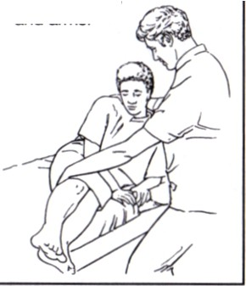
for lifting and moving patients*
To help a patient
it up from bed:
- Raise the head of the bed. Position the patient on his or her side, facing you.
- Place one arm under the patient's shoulders and the other arm over the thighs.
- Draw the patient's legs over the edge of the bed. At the same time, lift the patient's upper body, helping him or her to a sitting position.
Encourage the patient to help by using
his or her legs
and arms.
To move a patient from a bed to a stretcher.
- Have at least one helper. Line up the stretcher next to the bed. Have the patient cross his or her arms. Have one person stand against the bed side and one against the stretcher side.
- From the bed side, use a turn sheet to roll the patient to his or her side. On the stretcher side, a helper slides a transfer board (or other sliding aid) into place. Roll patient back onto it.
- Slide the patient onto the stretcher. Remove the sliding aid. Fasten stretcher straps.

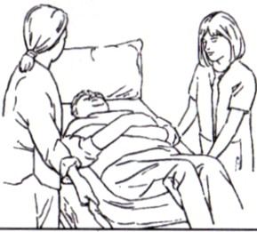
To use a turn sheet to move a patient up in bed:
- Have at least one other person help you. Stand on opposite sides of the patient. (A third helper may be needed to support the patient's legs.)
- Make sure the turn sheet extends from the patient's shoulders to the thighs.
- Protect the patient's head by placing a pillow against the headboard. Have him or her cross arms over chest and bend knees.
- Grasp the tum sheet at the patient's shoulders and buttocks. Pull it tight.
- Gently lift and move the patient to the headboard. At the same time, ask the patient to help by using his or her legs to push.
If you use another type of transfer sheet, such as one that inflates or has handles, follow all instructions for proper use. •

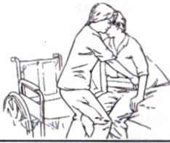
*The actual procedures you use may vary from the ones listed on pages 10-13. These examples are not a substitute for professional training.
To help a sitting patient from the bed to a chair.
- Lower the bed until the patient's feet rest flat on the floor. Face the patient. Use a transfer belt.
- Bend and align your knees with the patient's knees. Hold the patient by the belt.
- Lift the patient-while holding him or her close-to a standing position, using a rocking motion. Have the patient support as much of
his or her weight as possible.
- Turn by moving your feet, helping the patient to do the same.
- Have the patient use the chair's arm rests for support. Gently help lower him or her into the chair. Have a second person guide the patient's hips, if needed.
Secure the safety belt.
Always follow your facility's procedures. Never try to move a patient unless you've been trained and have practiced proper lifting and moving procedures, including the use of equipment.
10

For all lifts:
- Make sure everyone knows what to do in advance, including
the patient.
- Give commands out loud
(or count out loud) for each step.
- Move at the same time. Avoid sudden, jerky movements.
- Encourage the patient to help at each step to the best of his or her abilities.

11

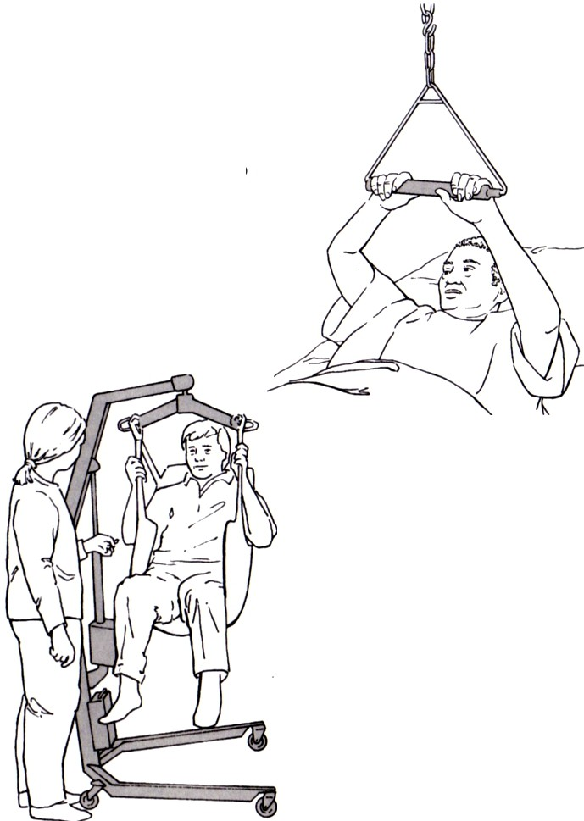
Use equipment properly.
Overhead trapeze
Use this device to help a patient with good physical abilities sit up in bed. Have the patient:
- bend knees
- put feet flat on the bed
- grab the bar with both hands
- lift and pull with arms, while pushing with legs and feet.
Lift or hoist
These can be used for many types of transfers. Some facilities require these for all patients when certain lifts and/or moves are being done. In general:
- Have at least one helper.
- Follow the manufacturer's instructions and your facility's procedures.
- Secure and check all attachments before starting to lift the patient.

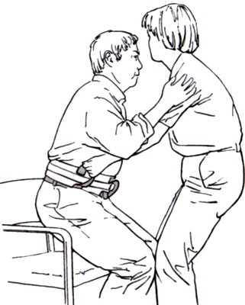
Remember to check equipment before each use. Make sure it's been approved for the patient's condition and type of move.

Transfer belt
Some facilities require these
for all manual lifts and/or moves.
  - Make sure the belt fits properly-snug around the waist, but not too tight.
  - Use the belt-not the patient's arms or clothing-for grasping. In general, use an underhand grip (palms up), and a rocking and pulling (not a lifting) motion.
  - Remove the belt after the move.

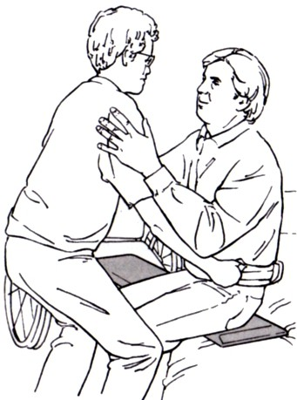
Sliding board
Use this device to help a patient who cannot stand alone move from a wheelchair to a bed.
    - Use a transfer belt.
    - Position the wheelchair at an angle, facing toward the bed. Lock the wheels.
    - Have the patient place both feet on floor. Move footrests out of the way.
    - Position the sliding board under the patient's thigh and resting on the bed.
    - Hold onto the belt and support the patient in rising from the chair and sliding across the board.

12

Remember to use proper body mechanics when using equipment. (See page 9.)
13

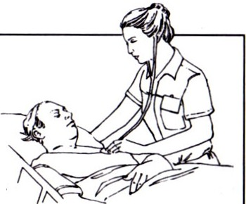
More tips
For your patients· health and safety:
- Take steps to protect their skin. Never drag patients across surfaces.
- Check their condition (pulse rate and blood pressure, for example) and level of comfort after the move. Update their chart, as needed.

For your health and safety:
  - Use proper posture when walking and sitting.
  - Do not use back belts (unless prescribed by your health-care provider).
  - Promptly report any hazards, mishaps or injuries.

  - If a patient starts to fall, help him or her to the floor, chair, bed or other safe surface. Spread your feet, bend your knees and maintain your back's natural curves. Never stretch or try to "catch" the patient-this could injure both of you.

For a healthy back:
Maintain a healthy weight. Combine regular exercise with a healthy diet. Consult your health-care provider before starting an exercise program. Do regular back exercises, as he or she recommends. For example:

- Pelvic tilt-lie flat, knees bent, • Knee-to-chest rais�ie flat, feet flat on floor. Tense stomach. legs straight. Grasp one knee Squeeze buttocks and lift hips and bring it close to chest. slightly off floor. Count to 10. Count to 10. Relax. Repeat. Relax. Repeat. (Pull up both legs at once for a

���

Give your back a break. Make the move to safety.
14

